# **Project 2**

Team members: Jessie, Xiao, Sanjay and Mitsuko

Mentor: Gage

Subject: Study of the energy consumption from 1960 to 2017 by US States

Data source: US energy information administration

<https://www.eia.gov/state/seds/seds-data-complete.php?sid=US#StatisticsIndicators>

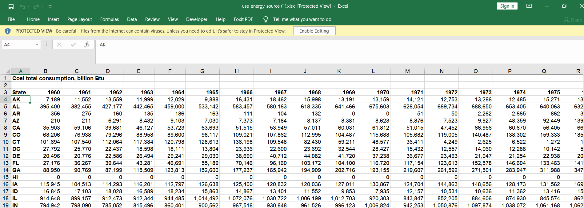

We picked “Energy consumption by source file”. The data file contains the coal, nuclear, petroleum, natural gas and total renewal energy usage for each State in British Thermal Units.

We will study for example the yearly trend, the consumption evolution by state, and also for USA as whole.

We plan to use flask, progress, python and Jupyter notebook.

Github repo: <https://github.com/pikako77/Project2>

Example of plot:

